Homework

Supporting your Child’s Learning in Primary 1

St Michael’s Primary
August 2019
Each child will receive a homework folder. Inside you will find:
- A homework diary detailing what work is to be completed at home each night, a list of the common words and space to record books your child has read. Please sign daily.
- A homework jotter containing the ‘choice’ grids and worksheets to be completed as indicated in your child’s homework diary.
- A zip-lock folder containing simple maths/language materials. This is for you to keep and use at home!
- A reading book which will be changed weekly.
Folders must be sent to school with your child every day. They will be kept on Fridays to allow time for corrections and to prepare for the following week.
Snacks & Lunch
Children are encouraged to bring a healthy snack for playtime. Only plain water is allowed. If your child brings a packed lunch please ensure they know what to have for their snack and what to leave for their lunch. Please do not send snacks containing nuts.
Gym Kits
Gym kits should include: shorts/leggings, soft indoor shoes and a blue polo-shirt. There can be no jewellery or accessories. If your child wears earrings please remove them before school as teachers cannot assist children in doing so, as per Glasgow City Council policy. There can be no football colours. Gym kits will be kept in school on the children’s pegs and will be sent home termly to be washed or changed. Please ensure that all of your child’s clothing is labelled.
Questions
If you have any comments or non-urgent questions for us feel free to note these in your child’s homework journal and we will respond by the following Monday.
If you have any pressing concerns or questions do not hesitate to contact us or the school.
Looking forward to working with you this year!
Primary 1A  Miss Rafferty & Miss Scott | Primary 1B  Mrs McIlwraith & Miss Healy
Welcome to St. Michael’s Primary! We’re looking forward to working with you and your child throughout the year. This information leaflet aims to help you to support your child’s learning at home and to answer any questions you may have.
Learning through Play
Glasgow City Council have recognised that as we strive for excellent and inclusive education within the city that we must respect the right of our children to play (Glasgow City Council, 2017). It is internationally acknowledged that children develop and grow through play. It is for this reason that infant classrooms across the city are implementing a play-based approach to learning. Your child will be provided with excellent opportunities to develop both, academically and socially through play-based teaching and learning methods. Your child will still experience all of the curricular areas through these play-based approaches.

Literacy
Phonological Awareness
Your child will begin developing their phonological awareness. This involves recognising and using initial sounds (/s/=sss, etc.). It is important that your child can identify letter sounds and letter names.
Jolly phonics jingles can be accessed on YouTube.
Important concepts at this stage of your child’s learning include:
- Rhyming (e.g. sun, bun, fun)
- Syllabification (e.g. flow-er, com-put-er)
- Alliteration (e.g. Peppa Pig, Mickey Mouse)
- Sound positioning (e.g. where do you hear the sound /c/ in the word cat?)
Sight Vocabulary & Reading Books
Your child will be given an Oxford Reading Tree book each week. Characters and key words will be taught at each stage. Fry’s common words lists will also be issued each term. Children will begin with wordless books.
Fine Motor Skills & Writing
Small movements in wrists, hands and fingers will support pencil grip and in turn your child’s writing development and cutting skills.
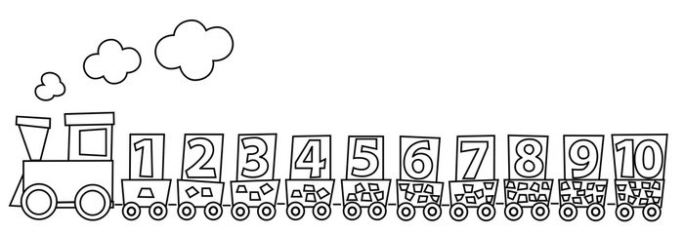
Numeracy

Throughout the year your child will be introduced to the fundamentals of number and maths. In number this will include things like number formation, estimation, counting forwards and backwards and more. In maths children will explore measure, shape and information handling.
Ways to Support your Child
Use everyday contexts. For example:
- When cooking encourage your child to measure ingredients. Discuss things that are heavy/light/full/empty.
- Discuss daily routines.
- When in the community look out for bus numbers, house numbers, shapes.
- Point out patterns.
- Allow for money interactions.
Useful Resources
- https://www.topmarks.co.uk
- http://www.doorwayonline.org.uk/number/
- YouTube: Number Jacks, Number Time, Jack Hartman
- Local Library
- Tens Frames and number lines

