2021 Digital Collaboration Challenge
WHAT?: Before the end of the 2020/21 year, we would like to challenge all of our teaching and support staff to share, investigate or teach a digital learning tool, tip or trick!
We DON’T expect everyone to present a workshop or make a video guide; you could test a new app in partnership with a colleague or even just show a staff member a digital tool that could help them.
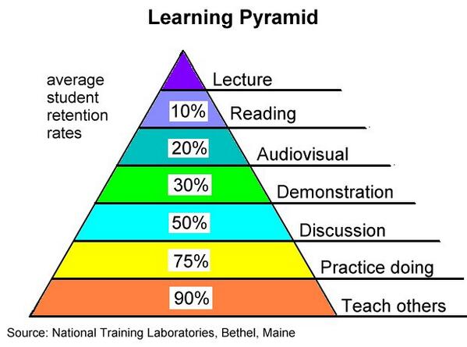
WHY?:
- We want to make the best use of digital tools to make learning better!
- Collaboration between staff is one of the key drivers of improvement.
- If we share our knowledge, the whole school gets wiser!
- We ALL have skills to contribute.
- WE RETAIN MORE KNOWLEDGE BY TEACHING OTHERS
HOW? Below are some examples to get us started. You can add more than one example of collaboration.
% of challenge complete | Name | App, Tool or Feature | Help a colleague(s) | Investigate with a stage partner or colleague | Make a video/picture guide for staff or families | Workshop for staff
3% | Mr Gallagher | Using Showbie
6% | Miss Rayner | Showbie tips and tricks
9% | Miss Healy | Using QR Codes
12% | Miss Neil | Using Plickers
15% | Miss Currie | Using voice reader for Showbie tasks
18%
21%
24%
27%
% of challenge complete | Name | App, Tool or Feature | Help a colleague(s) | Investigate with a stage partner or colleague | Make a video/picture guide for staff or families | Workshop for staff
30%
33%
36%
39%
42%
45%
48%
51%
54%
57%
60%
63%
66%
69%
72%
75%
78%
81%
84%
87%
90%
93%
96%
100%

