This is a quick start guide on how to access your pupil Showbie account. More support can be found on https://support.showbie.com/en/ or email us on showbiehelp@glow.sch.uk

Step 1: Visit www.showbie.com on your device (or if you have an Apple iPad or iPhone you can download the free Showbie app from the AppStore)

Step 2: click sign in (DO NOT CLICK SIGN UP as we have already made an account for you )
Step 3: Enter your Showbie username (this will be on the separate piece of paper attached) and enter your password (your password will be password 1) then sign in.
(***PLEASE NOTE*** password 1 HAS A SPACE BETWEEN THE WORDS AND NO CAPITALS)
Step 4: Click on your class (P1, P2, P3 etc)
Step 5: Click on an assignment on the left hand side
Step 6: This will reveal the assignment on the right hand side. Your teacher may leave instructions here. Click on the assignment to start work!
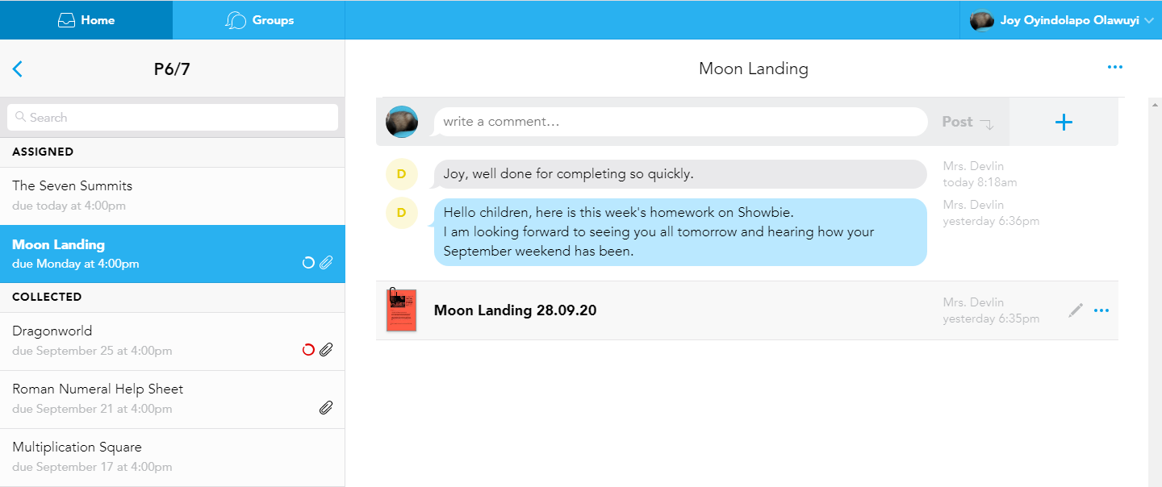
Step 7: Once you have clicked into the assignment you can do your task.
At the top of the screen you can use the Tools to do work on your assignment.
Your teacher may ask you to use the pen, a voice note or the text box to respond with answers to tasks.
TEXT BOX
VOICE NOTE
TEXT NOTE
RUBBER
HIGHLIGHTER
PEN
Step 8: Once you have finished click DONE at the top right to save your work.
Finally, check back in a few days to see or hear teacher comments.

